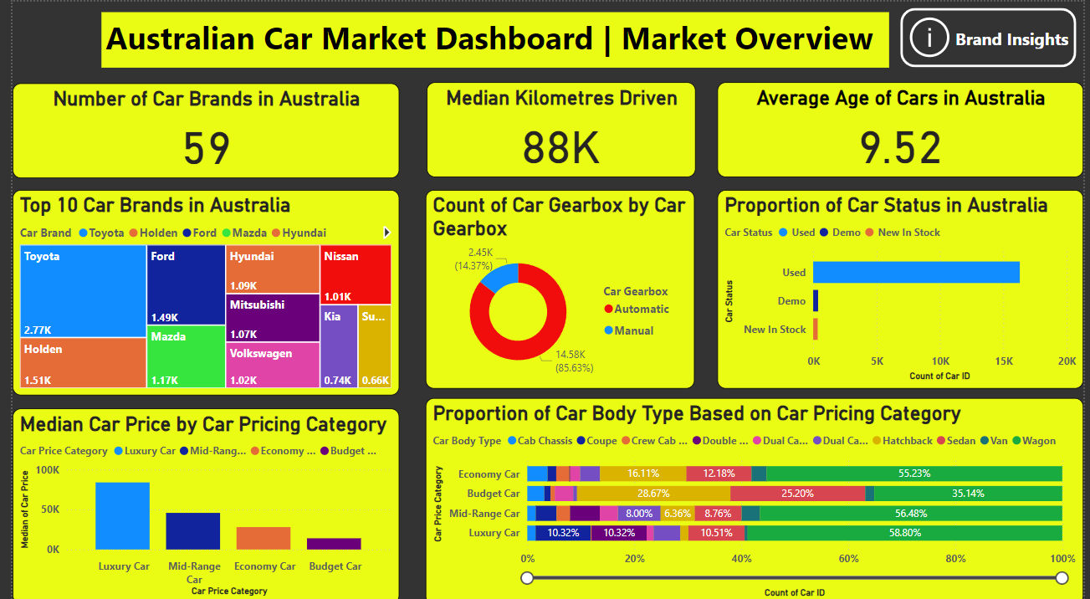

**Page 1 Overall Market Insights**

**Note: There is a button called “Brand Insights” on the top right corner of the dashboard, clicking it will lead to the Brand Specific Insights page where the user can look into brand specific details.**

**Page 2: Brand Specific Insights**

**Notes: There is a button called “Overall Market Insights” on the top right corner of the dashboard. Clicking it will lead to the Overall Marker Insights page where the user can look into the overall market details.**